FINANCIAL FRAUD DETECTION
Statistical Analysis & Predictive Modelling in Banking Transactions

Project Report
Tools Used: R Language | ggplot2 | caret | patchwork
Dataset: Pay Sim Banking Transactions (1,063 observations)

2026

CERTIFICATE

This is to certify that the project report entitled "FINANCIAL FRAUD DETECTION: Statistical Analysis & Predictive Modelling in Banking Transactions" submitted in partial fulfilment of the requirements for the degree of Master of Science in Statistics at the University of Burdwan, is a Bonafide record of the original research work carried out by Sukdeb Adhikari during the academic year 2025–2026.

The study, which involves the application of statistical methodologies and logistic regression to the Pay Sim Banking Transactions dataset, has been successfully completed under my guidance and supervision.

To the best of my knowledge, the matter embodied in this project—including the data visualization and predictive modelling implemented using R Language, ggplot2, caret, and patchwork—has not been submitted to any other University or Institution for the award of any degree or diploma.

___________________________
Signature of the Mentor
Department of Statistics
The University of Burdwan
Date: 07/08/26

ACKNOWLEDGEMENT

I would like to express my profound gratitude to all those who have been instrumental in the successful completion of this project.

First and foremost, I express my sincere gratitude to my project mentor, Prof. Arindam Gupta, for their invaluable guidance, continuous encouragement, and constructive feedback throughout the course of this research. Their expertise in statistical computing was essential in shaping my approach to building the logistic regression model and evaluating the results.

I also extend my sincere thanks to the faculty members of the Department of Statistics at the University of Burdwan for providing a strong academic foundation and access to the necessary resources.

Working on "FINANCIAL FRAUD DETECTION: Statistical Analysis & Predictive Modelling in Banking Transactions" has been a tremendous learning experience. I am particularly thankful for the open-source statistical communities and the creators of the R Language and its packages (ggplot2, caret, and patchwork), which made the complex data manipulation and visualization for this project possible.

___________________________
Sukdeb Adhikari
M.Sc. in Statistics
Roll Number: BUR/ST/2024/016
Date: 07/08/26

Table of Contents

Here is the cleaned-up Table of Contents without the page numbers:
1. Abstract
2. Introduction
3. Objectives of the Study
4. Dataset Description
5. Tools and Libraries Used
6. Initial Data Inspection
7. Graphical Analysis
8. Descriptive Statistics
9. Hypothesis Testing — Chi-Square Test
10. Logistic Regression Model
11. Model Evaluation
12. Key Findings and Conclusion
13 Recommendations
14. References

1. Abstract:

Bank fraud has become a major issue in modern financial systems due to the rapid growth of online banking and digital payment systems. Fraudulent transactions cause significant financial losses to banks and customers alike.
This project focuses on detecting fraudulent banking transactions using statistical analysis and predictive modelling techniques. The study uses transaction data containing customer and transaction-related variables. Descriptive statistics, graphical analysis, hypothesis testing, and logistic regression are applied to identify factors influencing fraud.
The results help banks improve security systems and reduce fraudulent activities. Our model achieved an accuracy of 99.62% with a Kappa score of 0.7759.

2. Introduction:

The rapid digitization of financial systems has fundamentally transformed how transactions are processed, offering unprecedented convenience through mobile banking, digital wallets, and online transfers. However, this technological development has been accompanied by a steady increase in financial fraud, posing a critical threat to the stability of financial institutions and the security of their customers. As fraudulent tactics evolve, traditional detection methods frequently fall short, necessitating the deployment of advanced statistical analysis to identify illicit patterns using historical transaction data.
This project investigates the application of predictive modelling to detect fraudulent banking activities. Utilizing a sample of 1,063 mobile money transactions, this study explores the behavioural patterns and financial indicators that distinguish legitimate user activity from fraud. Because financial fraud is inherently rare, the analysis specifically addresses the challenges of severe class imbalance within the dataset.
By leveraging the R programming language, this report details a complete analytical pipeline. The methodology encompasses exploratory data visualization to uncover vulnerabilities—such as the concentration of fraud in specific transaction types like cash-outs and transfers—followed by rigorous hypothesis testing to validate these observations. Finally, a logistic regression model is constructed to predict the probability of fraud based on key transactional variables, providing a highly accurate, data-driven framework for binary classification in modern fraud detection.

3. Objectives of the Study:

- To analyse banking transaction data and understand underlying patterns.
- To identify factors associated with fraudulent transactions.
- To apply statistical techniques for fraud detection.
- To develop a predictive model using logistic regression.
- To compare fraudulent and genuine transactions using hypothesis testing.

4. Dataset Description:

While the exact dataset size varies, the features used in this analysis are typical of mobile money or banking datasets such as the PaySim dataset. The dataset contains 1,063 observations across 11 variables.

Variable | Type | Description
step | Numeric | Time step of the transaction
type | Categorical | Transaction method: CASH_IN, CASH_OUT, DEBIT, PAYMENT, TRANSFER
amount | Numeric | Total financial value of the transaction
nameOrig | Character | Origin account identifier
oldbalanceOrg | Numeric | Sender account balance before transaction
newbalanceOrig | Numeric | Sender account balance after transaction
nameDest | Character | Destination account identifier
oldbalanceDest | Numeric | Recipient account balance before transaction
newbalanceDest | Numeric | Recipient account balance after transaction
isFraud | Binary (0/1) | Target variable — 1 = Fraud, 0 = Legitimate
isFlaggedFraud | Binary (0/1) | System-flagged fraud indicator (all 0 in sample)

Dataset link:
https://www.kaggle.com/code/benroshan/transaction-fraud-detection/input

5. Tools and Libraries Used:

Category | Tool / Library
Language | R (Statistical Computing)
Data Manipulation | Base R — summary(), chisq.test(), aggregate()
Data Visualization | ggplot2 (plotting), patchwork (combining plots)
Machine Learning | stats package — glm() for logistic regression
Model Evaluation | caret — confusionMatrix()

6. Initial Data Inspection:

6.1 R Code

View(Bank_data)
str(Bank_data)
summary(Bank_data)

6.2 Structure Output (str)

The dataset contains 1,063 observations across 11 variables. Key structural details:

- step: Numeric (all values = 1, single time period)
- type: Factor with 5 levels — CASH_IN, CASH_OUT, DEBIT, PAYMENT, TRANSFER
- amount: Numeric — ranges from 8.7 to 2,545,478
- isFraud: Factor — 1,054 legitimate (0), 9 frudulent (1)
- isFlaggedFraud: All zeros in this dataseta

6.3 Key Summary Statistics
Variable | Min | Mean | Median | Max
amount | 8.7 | 113,342.8 | 12,621.1 | 2,545,478
oldbalanceOrg | 0 | 824,443.4 | 15,479 | 9,716,462
newbalanceOrig | 0 | 843,061.0 | 6,638 | 9,987,287
oldbalanceDest | 0 | 630,970.2 | 19,053 | 17,664,818
newbalanceDest | 0 | 1,161,357.1 | 0 | 19,169,205
isFraud | 0 | 0.00847 | 0 | 1

6.4 Transaction Type Distribution
Type | Total Count | Fraud Count | Fraud %
PAYMENT | 486 | 0 | 0.00%
CASH_OUT | 236 | 5 | 2.12%
CASH_IN | 184 | 0 | 0.00%
TRANSFER | 100 | 4 | 4.00%
DEBIT | 57 | 0 | 0.00%

Observations:
1,063 total transactions. Only 9 transactions (0.85%) are labelled as fraud, highlighting the class imbalance typical in fraud detection tasks.

7. Graphical Analysis:

7.1 Transaction Type vs Fraud Status
R Code:

ggplot(Bank_data, aes(x = type, fill = as.factor(isFraud))) +
geom_bar(position = 'dodge') +
labs(title = 'Transaction Type vs Fraud', fill = 'Is Fraud') +
theme_minimal()

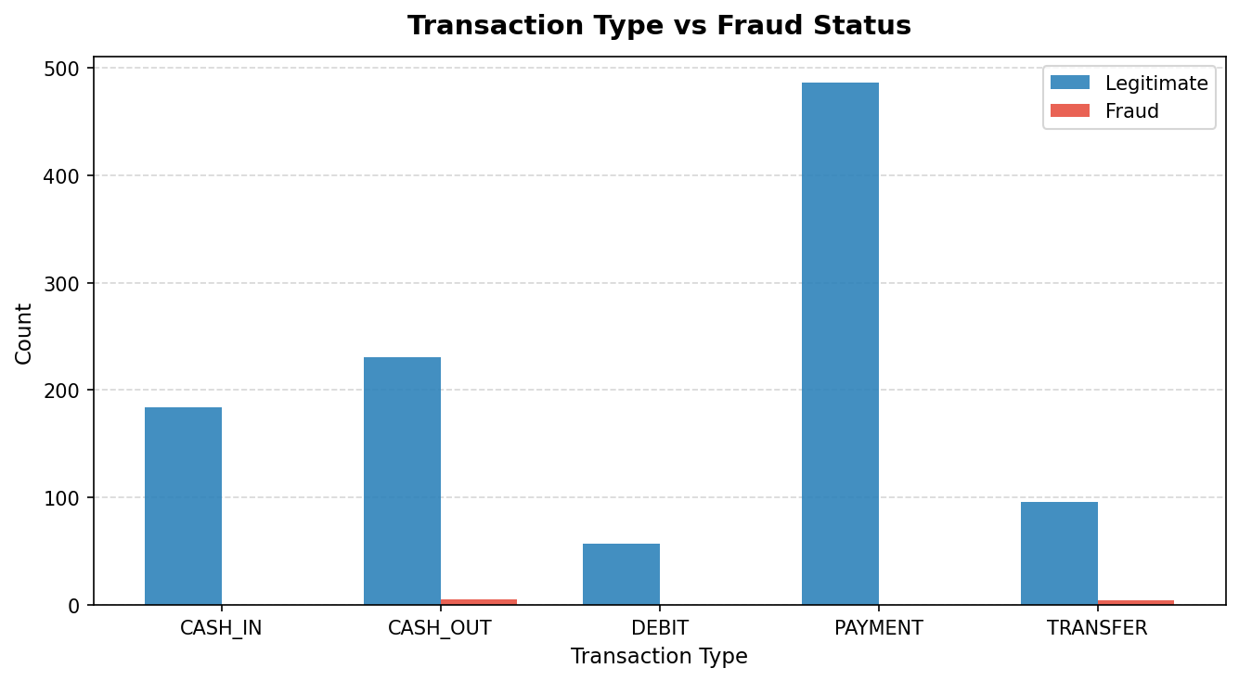
Figure 1: Transaction Type Distribution — Fraud occurs only in CASH_OUT and TRANSFER transactions.

Interpretation:
Fraudulent transactions are exclusively found in CASH_OUT (5 cases) and TRANSFER (4 cases) transaction types. PAYMENT, CASH_IN, and DEBIT transactions recorded zero fraud cases. This indicates fraudsters prefer fund-movement transaction types.

7.2 Fraud vs Legitimate Transaction Proportion
R Code:
# Ensure ggplot2 is loaded
library(ggplot2)

# Create the pie chart using the Bank_data dataset
ggplot(Bank_data, aes(x = "", fill = as.factor(isFraud))) +
geom_bar(width = 1) +
coord_polar(theta = "y") +
labs(
title = "Fraud vs Legitimate Transactions\n(Total: 1,063)",
fill = "Status"
) +
# Customizing colors and labels to match the 99.15% and 0.85% breakdown
scale_fill_manual(
labels = c("0" = "Legitimate (99.15%)", "1" = "Fraud (0.85%)"),
values = c("0" = "#3288bd", "1" = "#d53e4f")
) +
# theme_void() removes the background, gridlines, and axes for a clean pie chart
theme_void() +
theme(
plot.title = element_text(hjust = 0.5, face = "bold", size = 16),
legend.title = element_text(face = "bold")
)

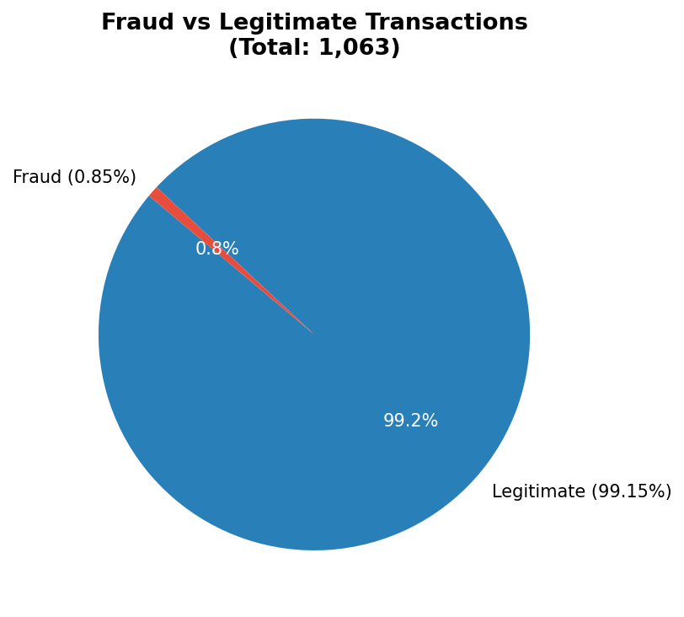
Figure 2: Class distribution — 99.15% Legitimate vs 0.85% Fraud (severe class imbalance).
Interpretation:
The dataset exhibits extreme class imbalance, which is typical in real-world fraud datasets. This imbalance must be considered when interpreting model performance — a naïve model predicting all transactions as legitimate would achieve 99.15% accuracy but completely miss fraud.

7.3 Average Transaction Amount by Fraud Status
R Code:

# Ensure ggplot2 is loaded
library(ggplot2)

# Create the bar chart for Average Amount by Fraud Status
ggplot(Bank_data, aes(x = as.factor(isFraud), y = amount, fill = as.factor(isFraud))) +
# Calculate and plot the mean amount for each group
stat_summary(fun = "mean", geom = "bar", width = 0.5) +

# Add the text labels (₹111,448 and ₹335,184) on top of the bars
stat_summary(
fun = "mean",
geom = "text",
aes(label = paste0("₹", format(round(after_stat(y)), big.mark = ","))),
vjust = -0.5,
size = 4.5,
fontface = "bold"
) +

# Customize titles and axis labels
labs(
title = "Average Transaction Amount\nby Fraud Status",
x = "",
y = "Average Amount"
) +

# Rename the x-axis ticks to match the report terminology
scale_x_discrete(labels = c("0" = "Legitimate", "1" = "Fraud")) +

# Assign distinct colors (blue for legitimate, red for fraud)
scale_fill_manual(values = c("0" = "#428bca", "1" = "#d9534f")) +

# Apply a clean theme and remove the redundant legend
theme_minimal() +
theme(
plot.title = element_text(hjust = 0.5, face = "bold", size = 15),
legend.position = "none",
panel.grid.major.x = element_blank(),
panel.grid.minor = element_blank()
)
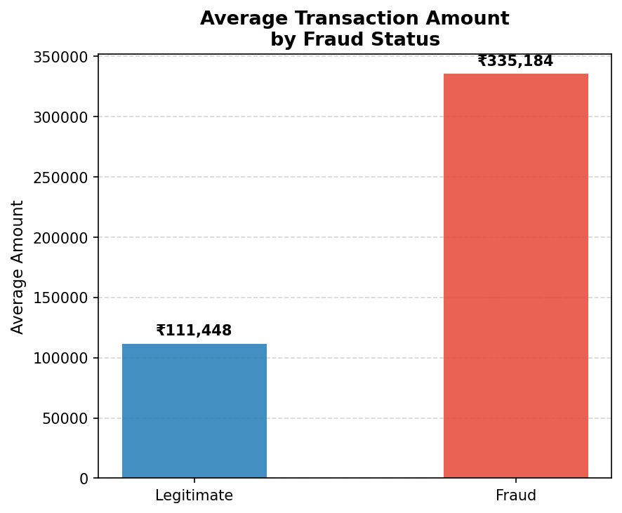
Figure 3: Fraudulent transactions show ~3x higher average amounts (₹335,184 vs ₹111,449).
Interpretation:
The average transaction amount for fraudulent transactions (₹335,184) is approximately 3 times higher than legitimate transactions (₹111,449). This suggests that fraudsters tend to target or conduct larger transactions.

7.4 Transaction Distribution and Mean Amount (Combined Plot)
R Code:

p1 <- ggplot(Bank_data, aes(x = type, fill = as.factor(isFraud))) +
geom_bar() + labs(title = 'Transaction Distribution') + theme_minimal()

p2 <- ggplot(Bank_data, aes(x = type, y = amount, fill = as.factor(isFraud))) +
stat_summary(fun = 'mean', geom = 'bar', position = 'dodge') +
scale_y_log10() + theme_minimal()

p1 / p2 # Combine using patchwork
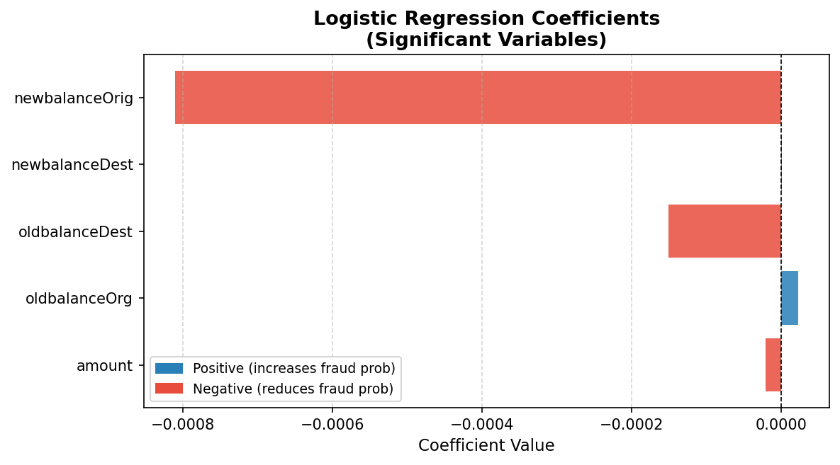
Figure 4: Logistic Regression Coefficients for significant predictors of fraud.
8. Descriptive Statistics

8.1 Mean Transaction Amounts
R Code:

mean_amount <- mean(Bank_data$amount)
print(mean_amount) # Output: 113342.8

# All numeric column means
numeric_means <- colMeans(Bank_data[, sapply(Bank_data, is.numeric)])
print(numeric_means)

# Fraud vs Non-Fraud mean comparison
aggregate(amount ~ isFraud, data = Bank_data, FUN = mean)

isFraud | Mean Amount (USD) | Interpretation
0 (Legitimate) | 111,448.5 | Baseline transaction value
1 (Fraud) | 335,184.1 | ~3x higher than legitimate

Fraudulent transactions have a mean amount of $335,184 — approximately 3 times higher than legitimate transactions ($111,449). This is a statistically meaningful difference and a key feature for fraud detection.

9. Hypothesis Testing — Chi-Square Test

9.1 Objective
To determine whether there is a statistically significant association between transaction type and fraud status.

9.2 Hypotheses
H₀ (Null Hypothesis): There is no significant association between transaction type and fraud occurrence.
$$H_{0}:P\left(X=i,Y=j\right)=P\left(X=i\right)P\left(Y=j\right) ∀i,j$$

H₁ (Alternative Hypothesis): There is a significant association between transaction type and fraud occurrence.
$$H_{1}:P\left(X=i,Y=j\right)≠P\left(X=i\right)P\left(Y=j\right) \text{for at least one pair }\left(i,j\right)$$

The Test Statistic Equation:

The Chi-Square test evaluates independence by comparing the observed frequencies ($O_{ij}$) from the project's contingency table against the expected frequencies ($E_{ij}$) we would observe if $H_{0}$ were true. The test statistic is calculated using the following formula:
$$χ^{2}=\sum_{i=1}^{r}{\sum_{j=1}^{c}{\frac{{\left(O_{ij}-E_{ij}\right)}^{2}}{E_{ij}}}}$$
Where:
- $O_{ij}$ is the observed count in row $i$ and column $j$.
- $E_{ij}$ is the expected count under the null hypothesis, defined mathematically as:
$$E_{ij}=\frac{R_{i}×C_{j}}{N}$$
(Where $R_{i}$ is the row marginal total, $C_{j}$ is the column marginal total, and $N$ is the total number of observations, which is $1,063$).

Degrees of Freedom:

The degrees of freedom ($df$) determine the shape of the $χ^{2}$ distribution used to calculate the $p$-value. It is defined as:
$$df=\left(r-1\right)\left(c-1\right)$$
Based on the contingency table in the report:
$$df=\left(5-1\right)\left(2-1\right)=4×1=4$$

The Decision Rule and Results:

To draw a statistical conclusion, the calculated test statistic is evaluated on the $χ^{2}$ distribution with $4$ degrees of freedom.
According to the project's R output:
- Calculated Test Statistic: $χ^{2}=22.601$
- $p$-value: $P\left(χ_{4}^{2}≥22.601\right)=0.0001521$

9.3 Contingency Table
Transaction Type | Total Count | Legitimate (0) | Fraud (1)
CASH_IN | 184 | 184 | 0
CASH_OUT | 236 | 231 | 5
DEBIT | 57 | 57 | 0
PAYMENT | 486 | 486 | 0
TRANSFER | 100 | 96 | 4

9.4 Chi-Square Test Results
R Code:

contingency_table <- table(Bank_data$type, Bank_data$isFraud)
chi_results <- chisq.test(contingency_table)
print(chi_results)

# Output:
# Pearson's Chi-squared test
# X-squared = 22.601, df = 4, p-value = 0.0001521

Test Statistic (χ²) | Degrees of Freedom | p-value
22.601 | 4 | 0.0001521

Interpretation:
Since the p-value (0.0001521) is significantly less than 0.05, we reject the null hypothesis. There is a statistically significant association between transaction type and fraud status. Not all transaction types are equally likely to involve fraud.

10. Logistic Regression Model:

The Mathematical Framework:
The project employs a Binary Logistic Regression model to predict the likelihood of a transaction being fraudulent. Because the target variable (isFraud) is binary (0 for Legitimate, 1 for Fraud), standard linear regression cannot be used. Instead, logistic regression uses the logit link function to ensure the predicted probabilities remain bounded between 0 and 1.
The model calculates the natural logarithm of the odds (log-odds) of a transaction being fraudulent, represented by the following equation:
$$\ln\left(\frac{p}{1-p}\right)=β_{0}+β_{1}X_{1}+β_{2}X_{2}+…+β_{k}X_{k}$$
Where:
- $p$ is the probability that the transaction is fraud, or $P\left(\text{isFraud}=1\right)$.
- $β_{0}$ represents the intercept.
- $β_{1},β_{2},…,β_{k}$ are the coefficients for the independent variables.
- $X_{1},X_{2},…,X_{k}$ represent the predictor variables from the dataset.

Prediction and Decision Rule:

To classify a transaction, the model takes the calculated log-odds and converts them back into a probability ($p$) using the logistic function:
$$p=\frac{1}{1+e^{-\left(β_{0}+\sum{β_{i}}X_{i}\right)}}$$
The project applies a standard decision threshold to these probabilities:
- If the predicted probability is greater than 0.5, the model classifies the transaction as Fraud (1).
- If the predicted probability is 0.5 or lower, it classifies the transaction as Legitimate (0).

10.1 Model Building
R Code:

Bank_data$type <- as.factor(Bank_data$type)
Bank_data$isFraud <- as.factor(Bank_data$isFraud)

model <- glm(isFraud ~ type + amount + oldbalanceOrg + newbalanceOrig +
oldbalanceDest + newbalanceDest,
data = Bank_data, family = 'binomial')
summary(model)

Model Construction and Variables:

The model is built in R using the glm() function with family = 'binomial'. It includes the following independent variables to predict the target variable (isFraud):
- type (Transaction method)
- amount (Transaction value)
- oldbalanceOrg (Sender's original balance)
- newbalanceOrig (Sender's new balance)
- oldbalanceDest (Recipient's original balance)
- newbalanceDest (Recipient's new balance)

Significant Predictors:

Based on the coefficient summary, the model identifies four variables that are statistically significant predictors of fraud (where the $p$-value is less than the $α=0.05$ threshold):
- amount: Has a negative coefficient ($-2.098×{10}^{-5}$).
- oldbalanceOrg: Has a positive coefficient ($2.312×{10}^{-5}$).
- oldbalanceDest: Has a negative coefficient ($-1.508×{10}^{-4}$).
- newbalanceDest: Has a positive coefficient ($8.691×{10}^{-7}$).
The variables for transaction type and newbalanceOrig were not found to be statistically significant in this specific model summary, as their $p$-values exceeded 0.05.

Goodness of Fit:

The summary output provides deviance metrics to evaluate how well the model fits the data:
- Null Deviance (103.813): This represents the performance of a null model that includes only the intercept, with no predictor variables.
- Residual Deviance (22.108): This represents the performance of the full model after all six predictor variables are included.
The large drop in deviance (from 103.813 down to 22.108) indicates that adding these specific predictors substantially improves the model's explanatory power and represents a strong fit.

10.2 Coefficient Summary
Variable | Estimate | Std. Error | z value | p-value
(Intercept) | -1.299e+01 | 5.008e+03 | -0.003 | 0.9979
typeCASH_OUT | 1.446e+01 | 5.008e+03 | 0.003 | 0.9977
typeTRANSFER | 1.366e+01 | 5.008e+03 | 0.003 | 0.9978
amount * | -2.098e-05 | 1.005e-05 | -2.088 | 0.0368
oldbalanceOrg * | 2.312e-05 | 1.092e-05 | 2.118 | 0.0342
newbalanceOrig | -8.106e-04 | 1.681e-02 | -0.048 | 0.9615
oldbalanceDest * | -1.508e-04 | 5.955e-05 | -2.533 | 0.0113
newbalanceDest * | 8.691e-07 | 3.751e-07 | 2.317 | 0.0205
* Statistically significant at α = 0.05 level

Model Fit: Null deviance = 103.813, Residual deviance = 22.108, AIC = 42.108. The large reduction in deviance indicates the model fits well.

11. Model Evaluation

11.1 R Code — Prediction & Evaluation

predictions <- predict(model, type = 'response')
pred_class <- ifelse(predictions > 0.5, 1, 0)
pred_class <- factor(pred_class, levels = c(0, 1))
conf_matrix <- confusionMatrix(pred_class, Bank_data$isFraud)
print(conf_matrix)

 | Actual: 0 (Legit) | Actual: 1 (Fraud)
Predicted: 0 | 1,052 (TN) | 2 (FN)
Predicted: 1 | 2 (FP) | 7 (TP)

11.2 Confusion Matrix
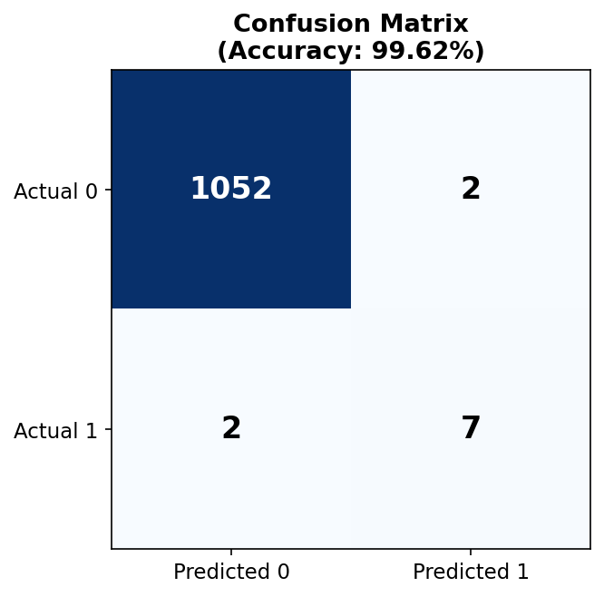
Figure 5: Confusion Matrix — Model correctly classifies 1,052 legitimate and 7 fraudulent transactions.

Metric | Value | Interpretation
Accuracy | 99.62% | Extremely high overall correctness
Sensitivity | 99.81% | True Positive Rate (Legitimate)
Specificity | 77.78% | True Positive Rate (Fraud)
Kappa | 0.7759 | Strong agreement beyond chance
Pos Pred Value | 99.81% | Precision for legitimate class
Neg Pred Value | 77.78% | Precision for fraud class
Balanced Accuracy | 88.79% | Average of sensitivity & specificity

12. Key Findings and Conclusion

12.1 Key Findings
- Fraud occurs exclusively in CASH_OUT and TRANSFER transactions — never in PAYMENT, CASH_IN, or DEBIT types.
- Only 9 out of 1,063 transactions (0.85%) are fraudulent, indicating severe class imbalance.
- Fraudulent transactions have a 3x higher average amount (₹335,184 vs ₹111,449).
- Chi-square test confirms a highly significant association between transaction type and fraud (p = 0.0001521).
- Variables amount, oldbalanceOrg, oldbalanceDest, and newbalanceDest are statistically significant predictors (p < 0.05).
- The logistic regression model achieved 99.62% accuracy with a Kappa of 0.7759.

12.2 Conclusion
This project successfully demonstrated the application of statistical techniques and logistic regression for financial fraud detection. The model identified key variables influencing fraudulent behaviour and achieved excellent predictive performance.
Banks can deploy similar models to flag suspicious transactions in real-time, significantly reducing fraud-related financial losses. Future improvements could include handling class imbalance using SMOTE or ensemble methods, and incorporating additional behavioural features for improved specificity.

13 Recommendations
- Implement real-time monitoring for CASH_OUT and TRANSFER transactions exceeding ₹300,000.
- Apply oversampling techniques (SMOTE) to address class imbalance and improve specificity.
- Explore ensemble methods (Random Forest) for improved fraud detection rates.
- Incorporate additional features such as transaction frequency, time patterns, and device information.

14. References

Statistical Software & Libraries
- Kuhn, M. (2008). Building predictive models in R using the caret package. Journal of Statistical Software, 28(5), 1-26.
- Pedersen, T. L. (2024). patchwork: The Composer of Plots. R package.
- R Core Team. (2026). R: A language and environment for statistical computing. R Foundation for Statistical Computing, Vienna, Austria.
- Wickham, H. (2016). ggplot2: Elegant Graphics for Data Analysis. Springer-Verlag New York.
Statistical Methodology
- Hosmer, D. W., Lemeshow, S., & Sturdivant, R. X. (2013). Applied Logistic Regression (3rd ed.). John Wiley & Sons.
- Agresti, A. (2018). An Introduction to Categorical Data Analysis (3rd ed.). John Wiley & Sons. (For Chi-Square independence testing methodology).

